9)
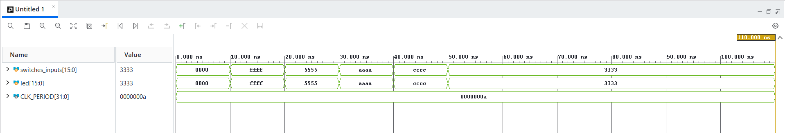

11)
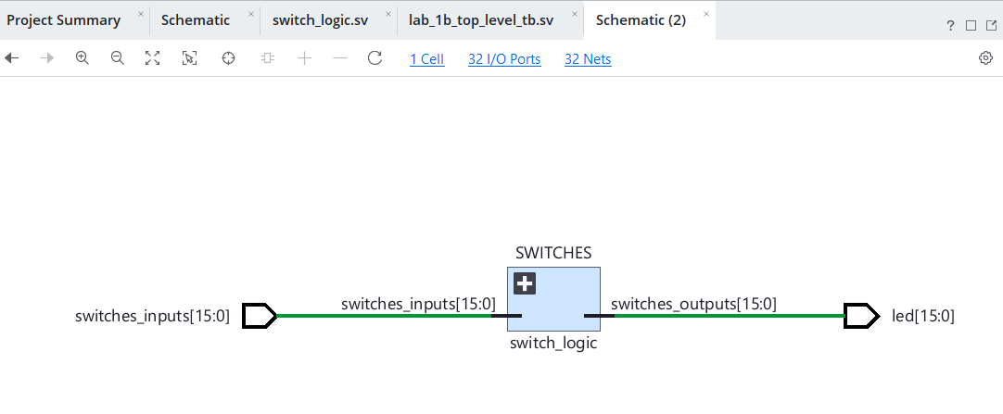

14)
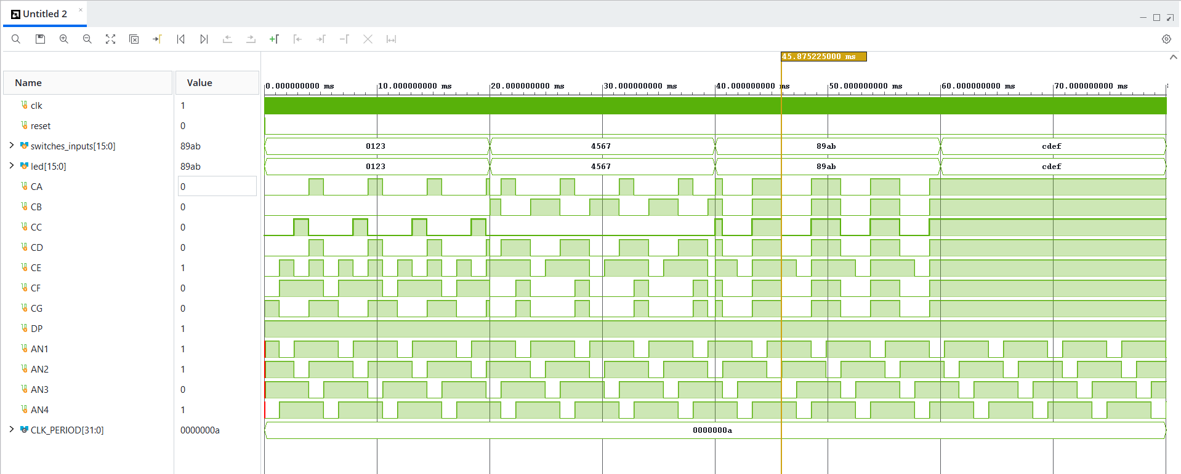

16)
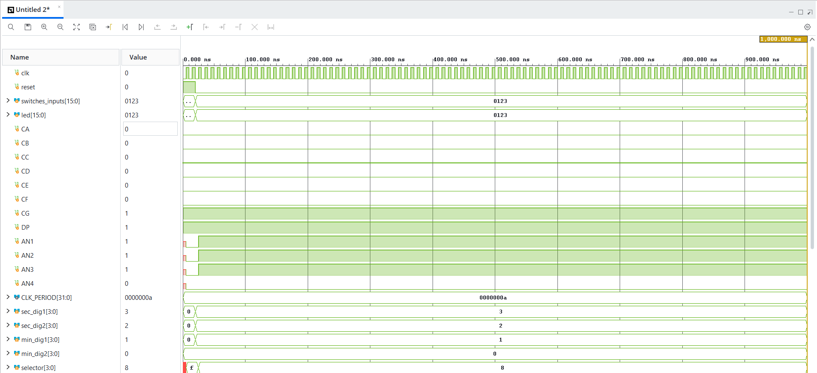
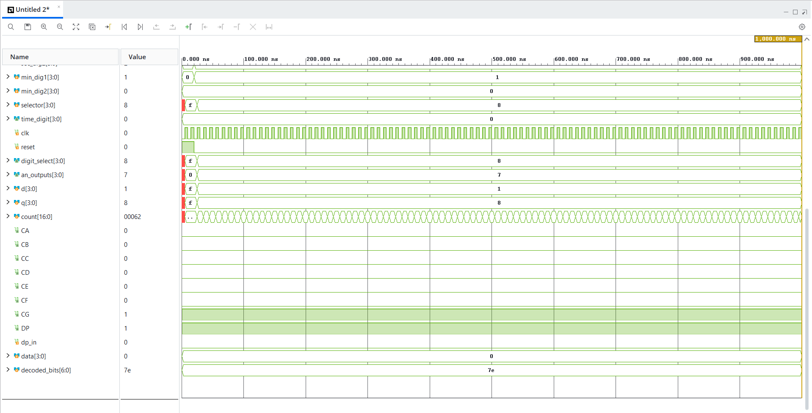

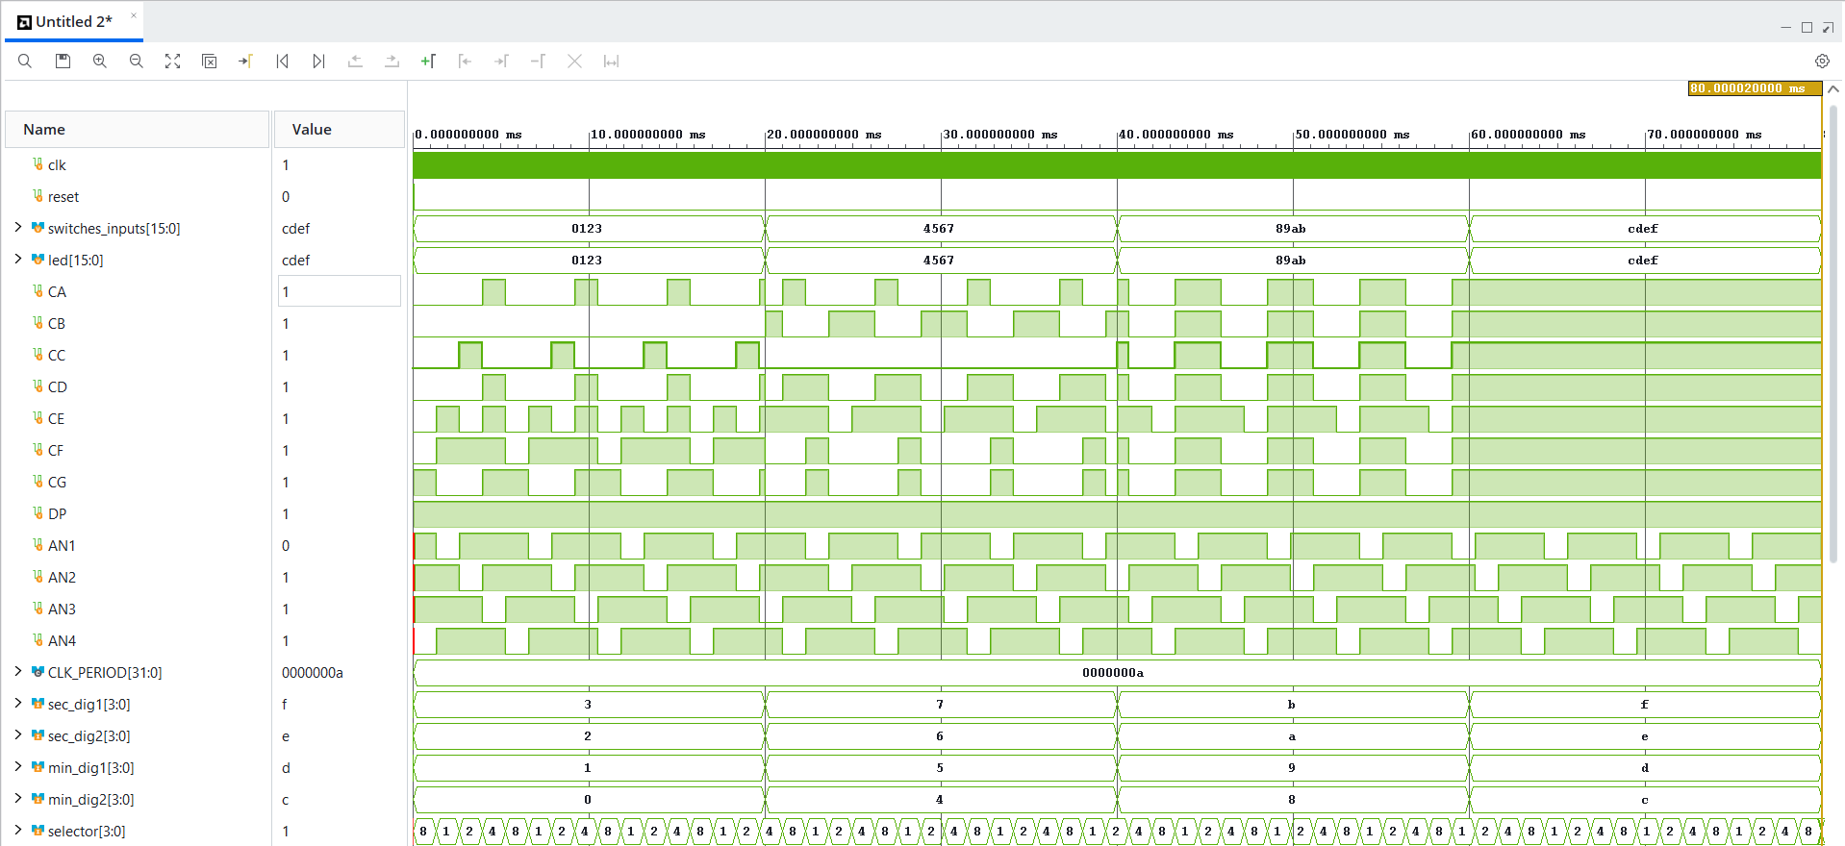

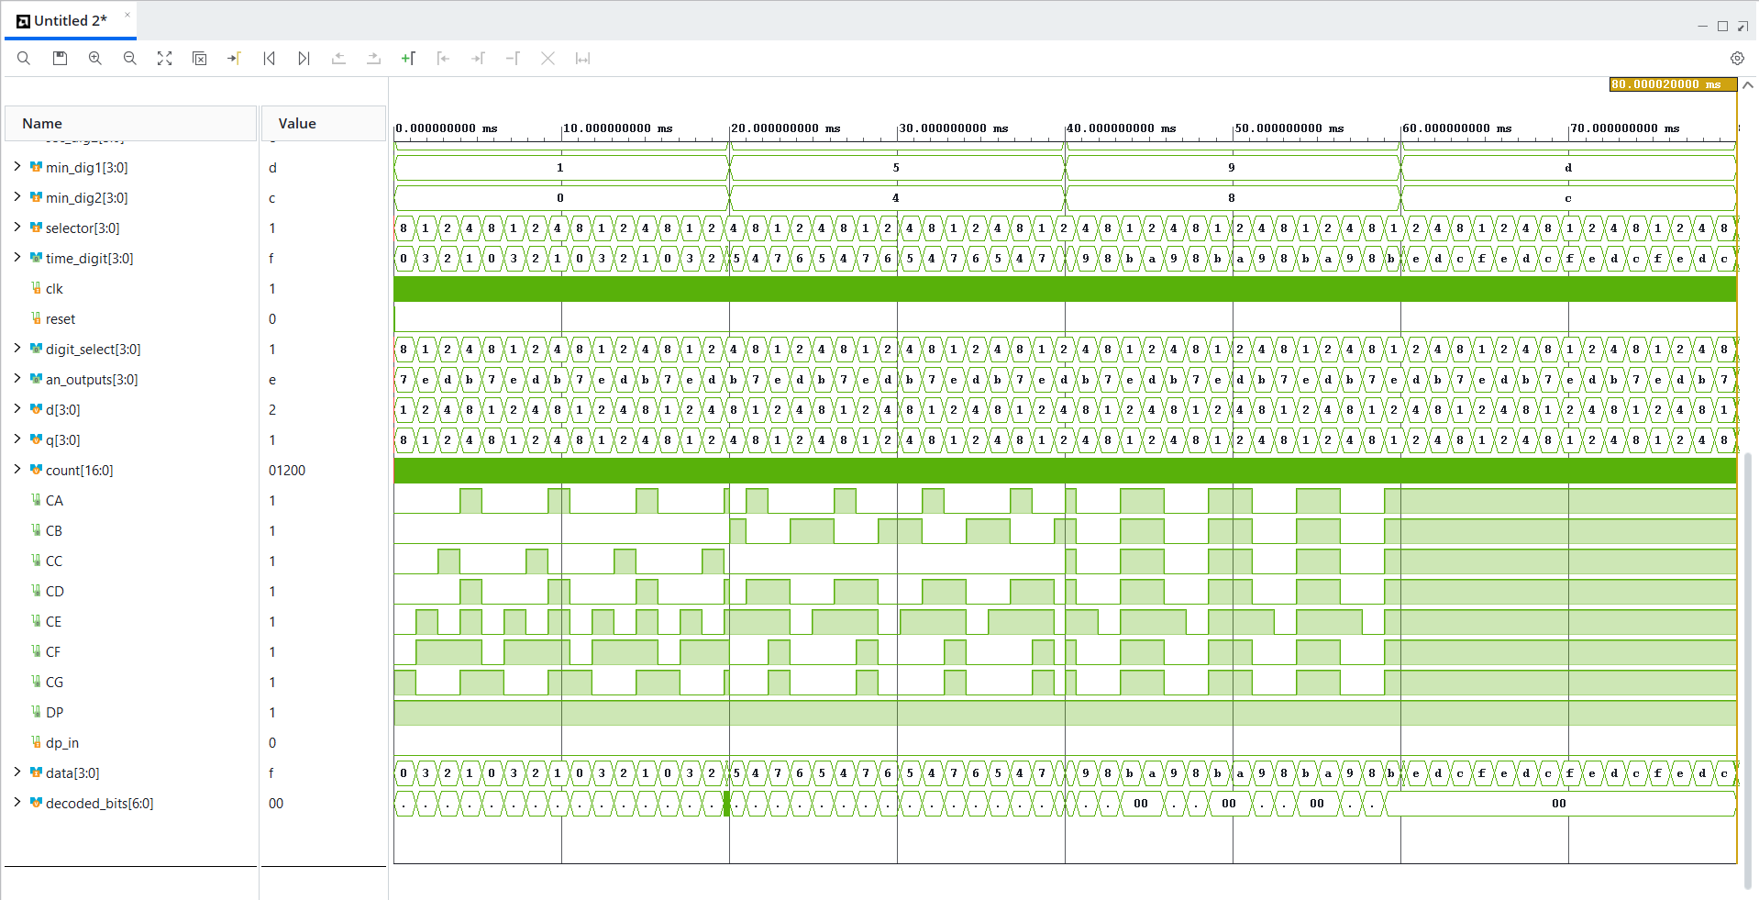

17)
For the first 4
it becomes
8000 – 4000_2000 1000

19)
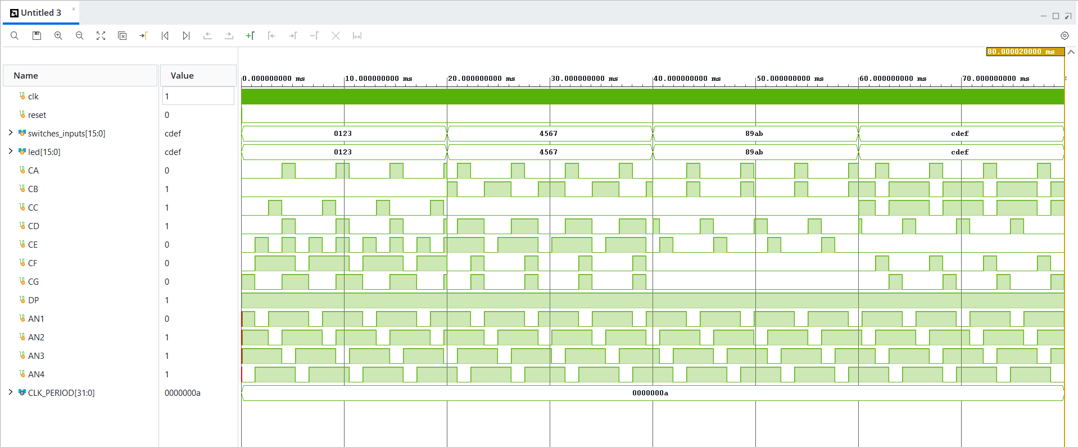

20)
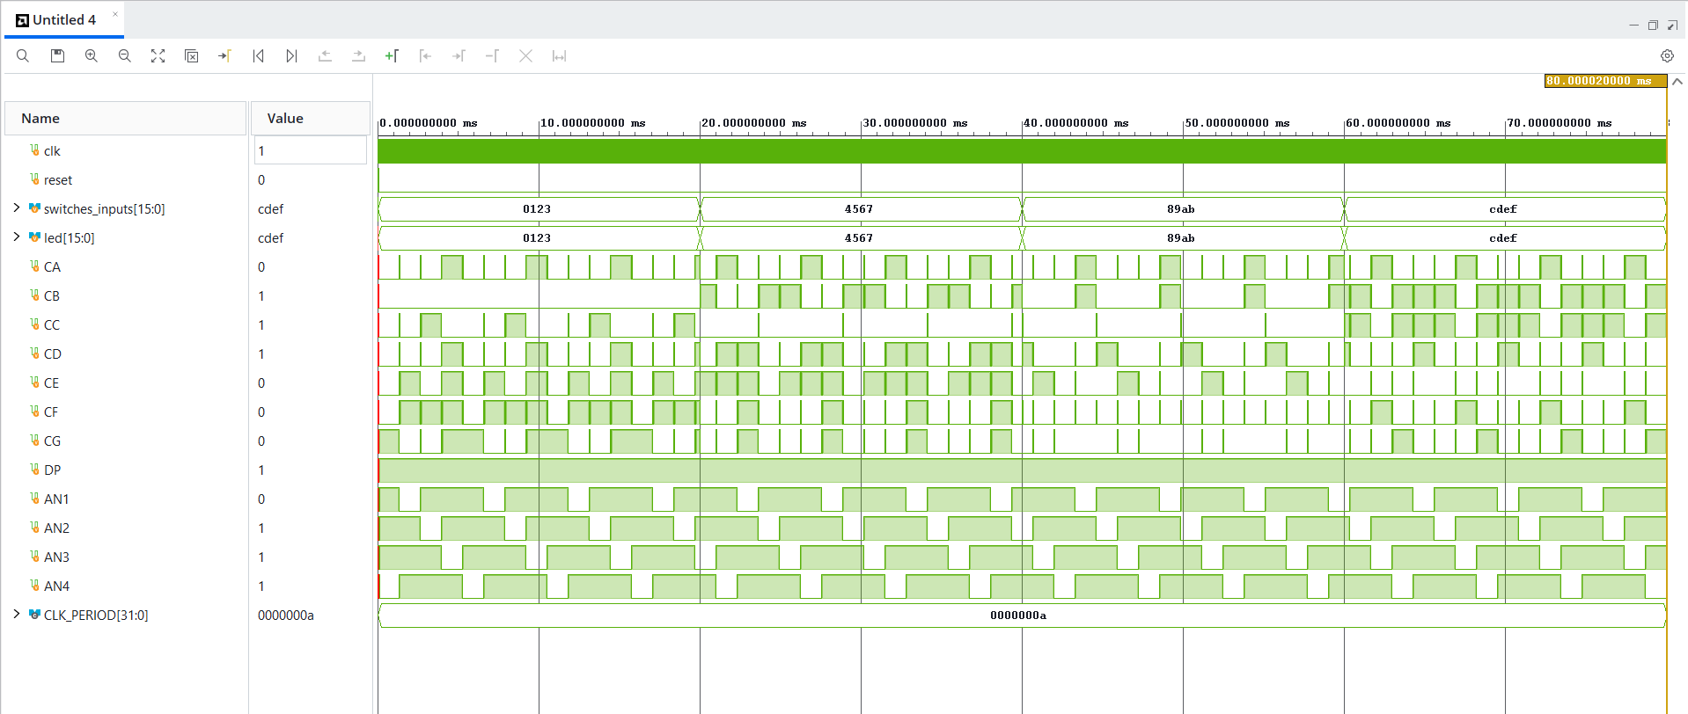
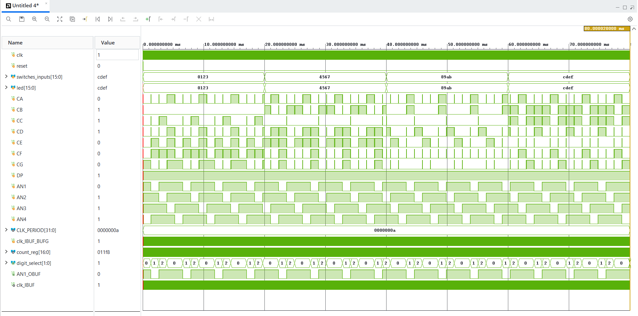
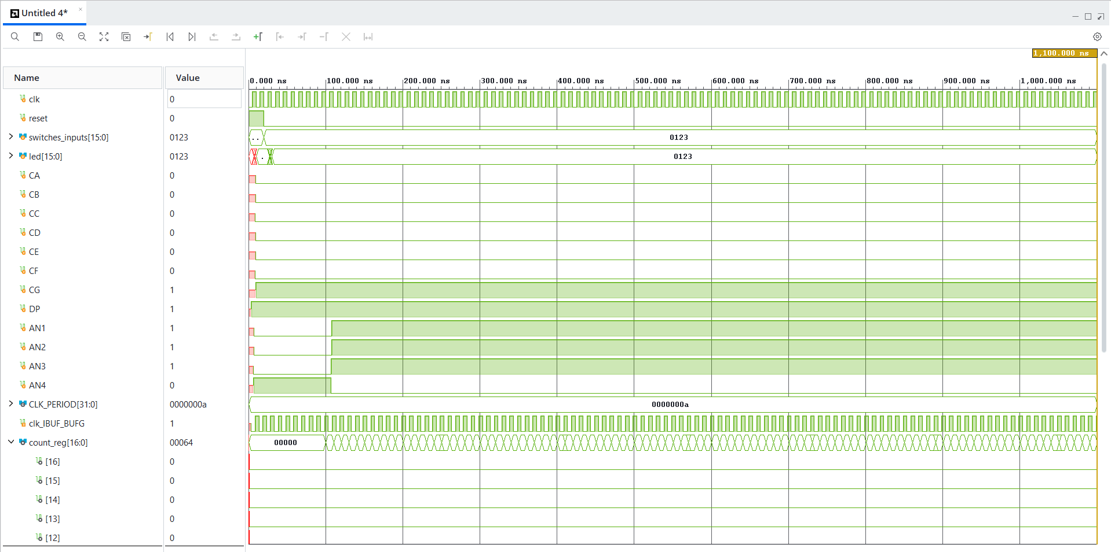

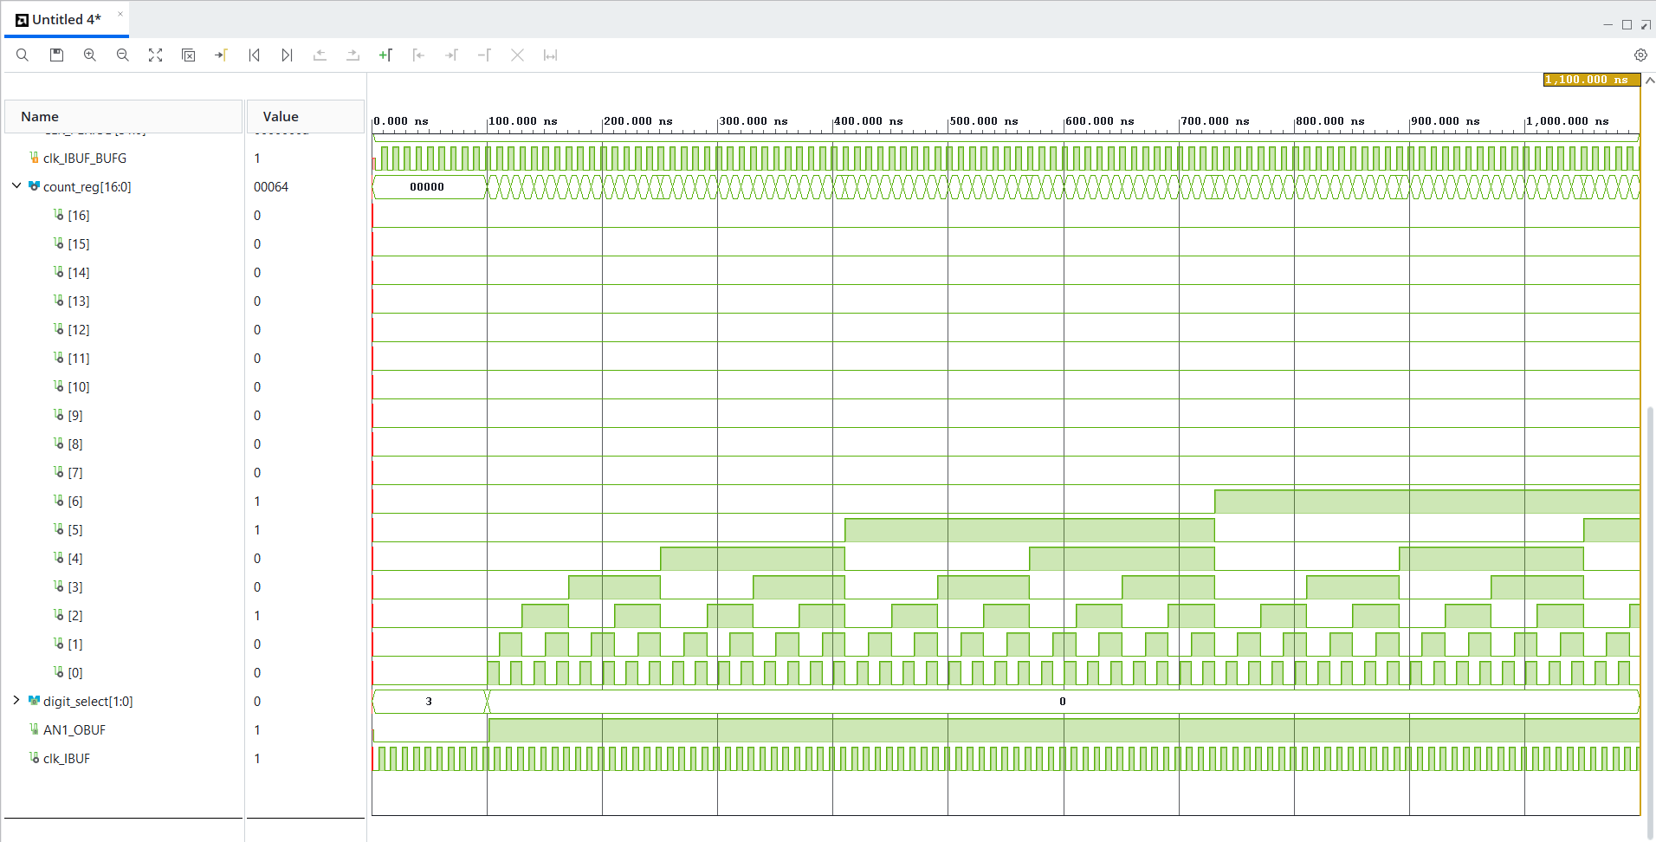

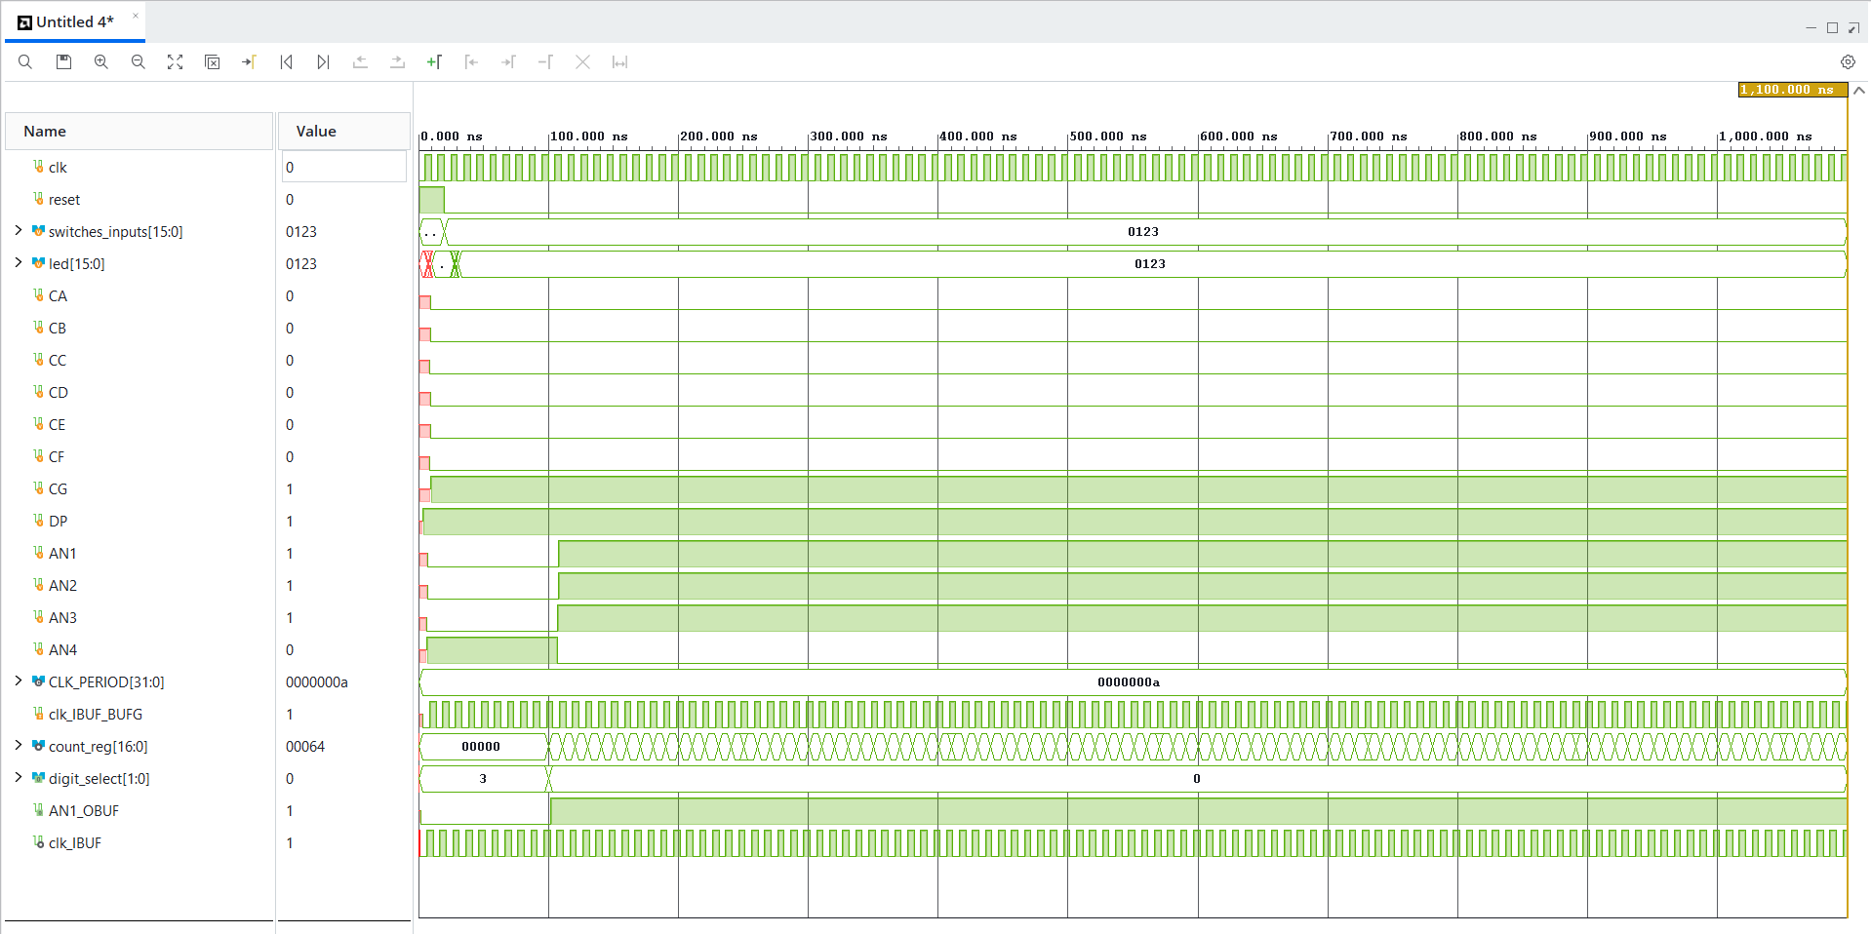

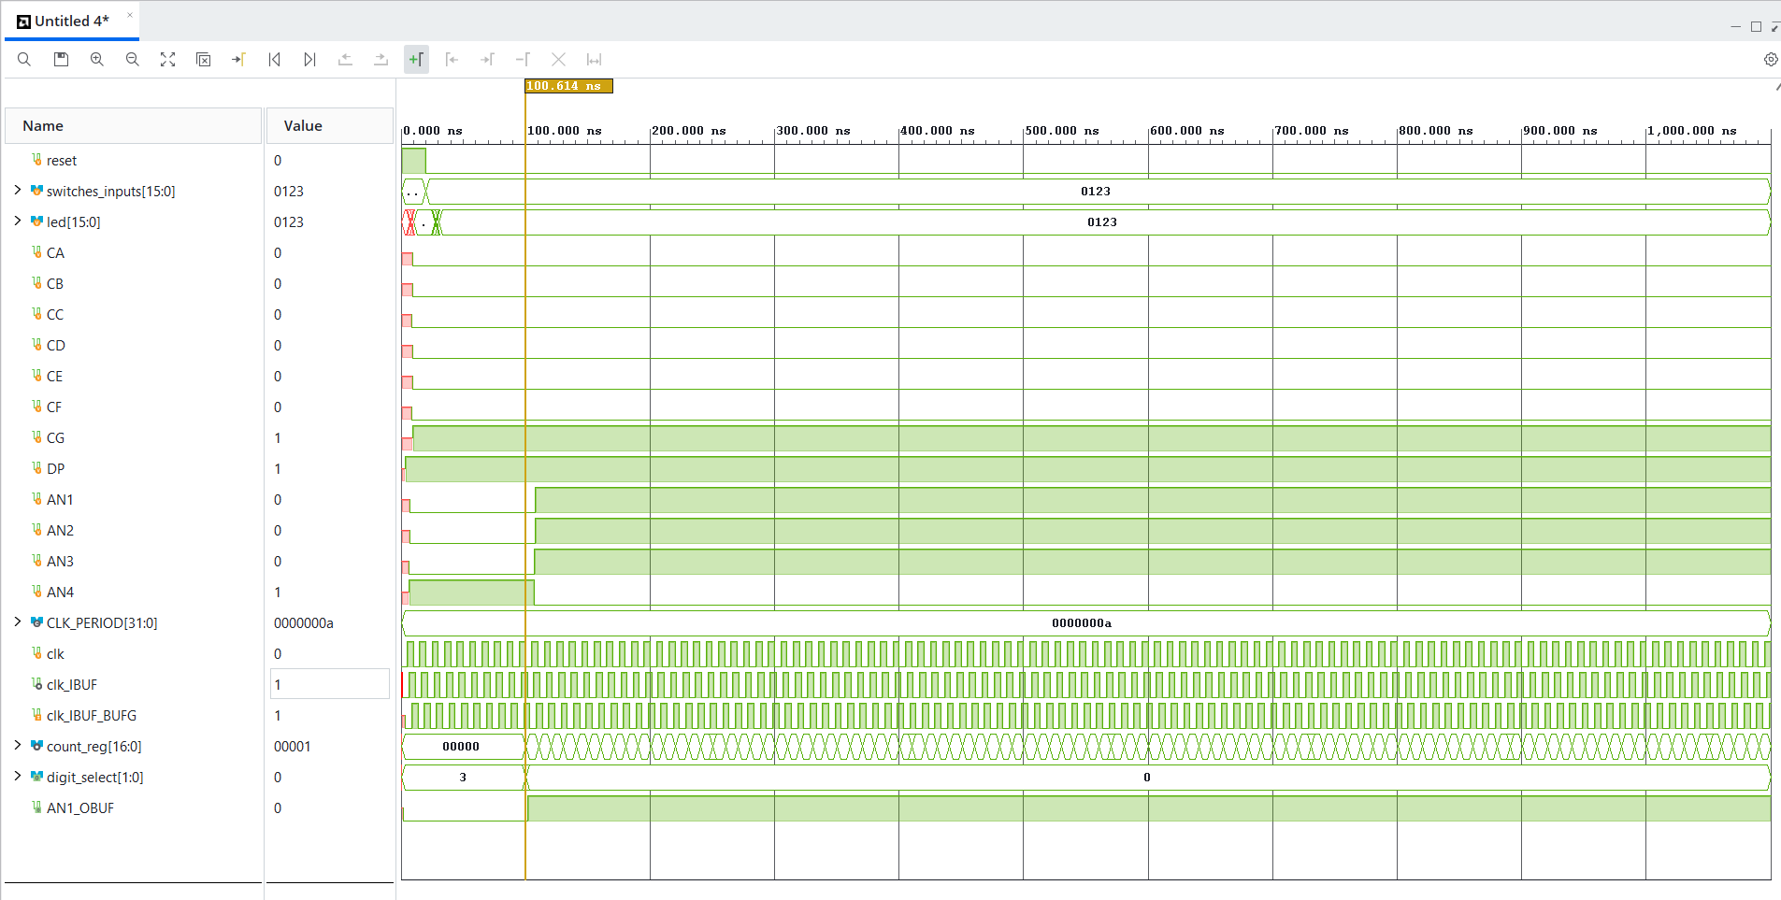

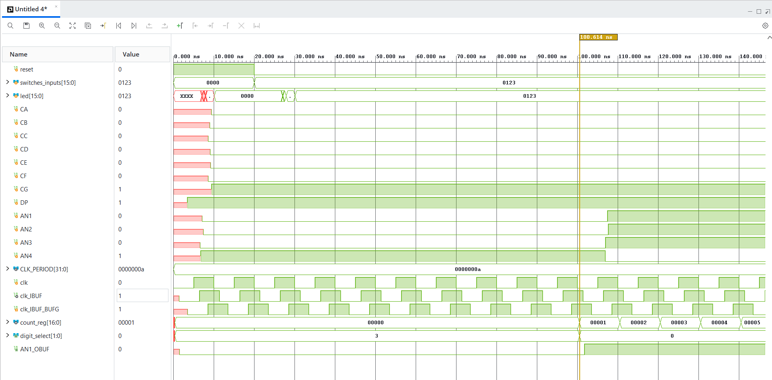

The Post-Implementation Timing Simulation shows physical propagation delays. The external clock passes through the input buffer and global clock buffer before reaching the internal circuit. The counter output changes shortly after the buffered clock edge, demonstrating clock-to-output delay. AN1_OBUF changes shortly after digit_select, demonstrating combinational logic delay.

22)
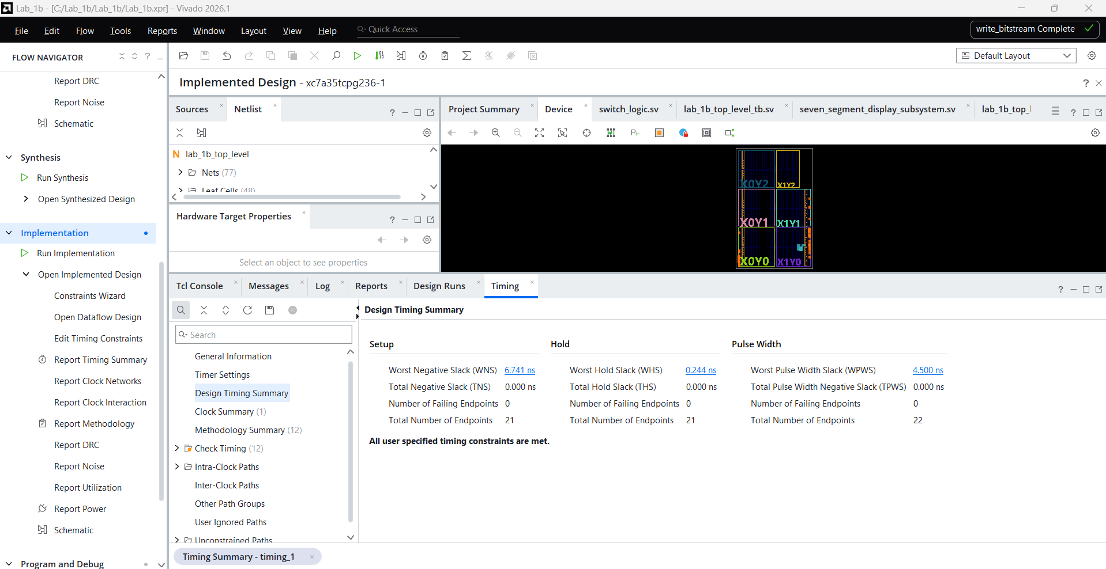

Calculate maximum frequency
Your desired clock period is:
$$10.00\text{ ns}$$
Use:
$$f_{max}=\frac{1000}{10.00-\text{WNS}} \text{MHz}$$
In an earlier screenshot, your WNS appeared to be 6.057 ns. If the Timing Summary confirms that value:
$$f_{max}=\frac{1000}{10.00-6.057} \\ f_{max}=\frac{1000}{3.943} \\ \boxed{f_{max}≈253.6 \text{MHz}}$$
Because:
$$253.6\text{ MHz}>100\text{ MHz}$$
your design meets timing.
Reason:
The reported WNS is 6.057 ns and the user clock period is 10.00 ns. The calculated maximum clock frequency is approximately 253.6 MHz. Since this is greater than the required 100 MHz clock frequency, the design meets timing.

Answer:
WNS = 6.741 ns
Failing endpoints = 0
“All user specified timing constraints are met.”
Calculation in Design Record:
$$\text{Minimum clock period}=10.000-6.741=3.259 \text{ns} \\ \text{Maximum clock frequency}=\frac{1000}{3.259}=306.84 \text{MHz}$$
The design has a WNS of 6.741 ns. Using a specified clock period of 10.000 ns, the minimum achievable period is 3.259 ns. Therefore, the maximum clock frequency is approximately 306.84 MHz. Since this exceeds the required 100 MHz and there are zero failing endpoints, the design meets timing.

